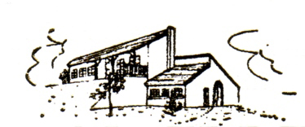

Domaine Fournier Sauvignon
Domaine Fournier Sauvignon is a dry, fresh white wine with a powerful aroma. It has a particular flavor originating from a mix of currant bushes in buds, grapes of table and passion fruits.
History: The origin of Sauvignon Blanc goes back in French history to the Middle Ages where it was introduced into the area of the “Cher” by the Bénédictine monks of l’Abbaye de Beauvoir. From the beginning of the 16th century, François the 1st spoke about it every time he resided in his castles in the Loire Valley.
Production surface: Nowadays, Sauvignon is cultivated from East and West of the appellation area, on the hills of the Loire Valley as well as the Poitou and the Vendée.
Suggested dishes: It accompanies perfectly oysters, seafood, the pate or goat's milk cheese.
Lively, with citrus-edged zip amid the mix of white peach, pink grapefruit and white asparagus flavors. Drink now. 25,000 cases made. -JM

Food & Wine Magazine recommends Domaine Fournier Sauvignon as a great alternative to Sancerre in the April 2019 issue.
Fournier is a top Sancerre estate, but their secret buy is this basic Loire Sauvignon Blanc—it’s a killer deal, full of zesty goose- berry and light herbal flavors.
https://www.foodandwine.com/wine/white-wine/sancerre-alternatives

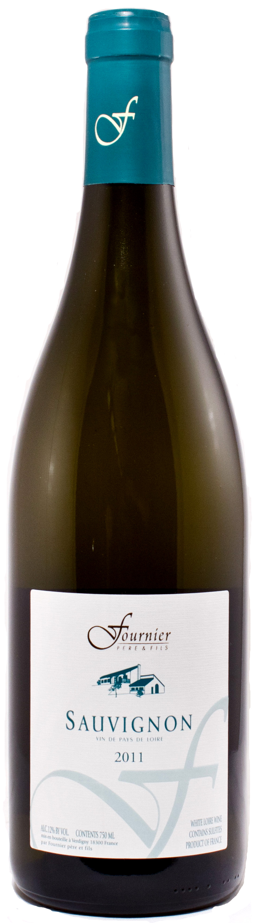

Claude Fournier is the 9th generation of his family to make wine. His wife, Eliane, is the 13th. After many years of hard work Domaine Fournier is now one of the most important estates in Sancerre.
The family has worked tirelessly to produce top quality wines; combining family winemaking traditions with advanced facilities including custom made tanks and a modern winery design that incorporates hand sorting of the grapes and the use of gravity to ensure delicate treatment of the must (juice). Over the last 50 years they have grown the Fournier Estate from their father's 13 acres to 222 acres in Sancerre, Pouilly Fume and Menetou Salon.

